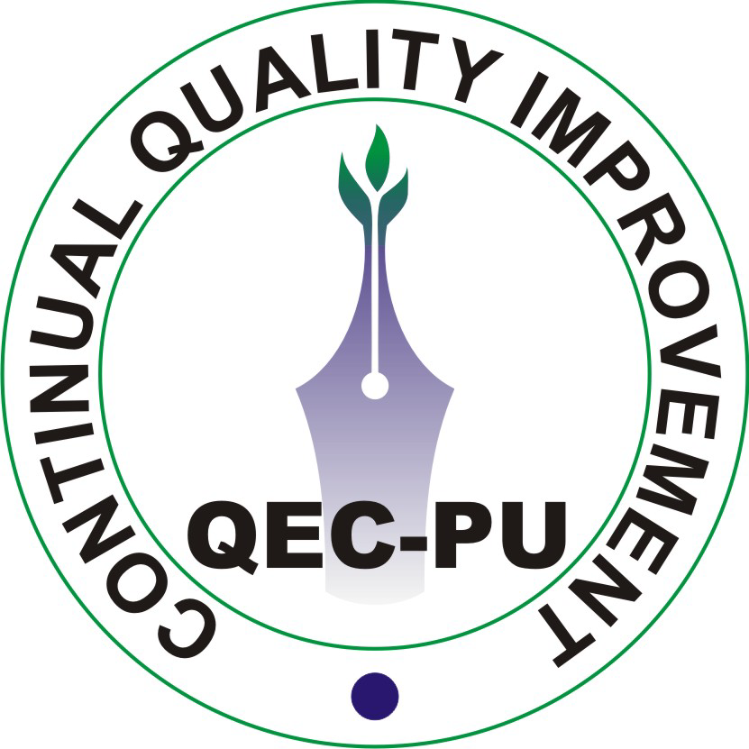 | QUALITY ENHANCEMENT CELL  University of the Punjab, Lahore.
Ref. No: 141 / QEC |  | Date: 04-11-2010

Prof. Dr. Hafiz Muhammad Iqbal,
Dean, Faculty of Education,
University of the Punjab, Lahore.

Subject: Minutes of Meeting for Expediting Self Assessment Activities of Faculty of Education.

Purpose of Meeting: To expedite the completion of Self Assessment Report
Scope of Meeting: Minutes of Visit to the Faculty of Education
Date of Meeting: 25-10-2010 (Monday)
Venue of Meeting: Committee room, Faculty of Education
Responsible Staff:
- Prof. Dr. Hafiz Muhammad Iqbal (Dean Faculty of Education)
- Dr. Abid Hussain Chaudhary (Department of Elementary Education)
- Dr. Abdul Qayyum (Department of Elementary Education)
- Ms. Ashi Zeshan (Department of Business Education)
- Ms. Ammara Saher (Department of Business Education)
- Dr. Muhammad Saeed Akhtar (Department of Islamic Education)
- Ms. Mubashira Khatoon (Department of Islamic Education)
- Mr. Abdul Majid Khan (Department of Islamic Education)
- Ms. Nighat Sana Kirmani (Department of Science Education)
- Mr. Ahmad Sher Awan (Department of Science Education)
- Dr. Tariq Mahmood (Department of Secondary Education)
- Dr. Tahseen Mahmood (Department of Technology Education)
In Attendance:
- Prof. Dr. Aamir Ijaz (Director QEC)
- Prof. Dr. Nasir Saeed Butt (Quality Assurance Advisor IQTM)
- Dr. Abid Hussain Chaudhary (Department of Elementary Education)
- Dr. Muhammad Saeed Shahid (Department of Elementary Education)
- Dr. Abdul Qayyum (Department of Elementary Education)
- Mr. Rizwan Akram Rana (Department of Science Education)
- Ms. Nighat Sana (Department of Science Education)
- Mr. Ahamd Sher Awan (Department of Science Education)
- Dr. Mumtaz Akhter (Chairperson Department of Secondary Education)
- Dr. Tariq Mahmood (Department of Secondary Education)
- Mr. Mubashira Khatoon (Department of Islamic Education)
- Dr. Tahseen Mahmood (Department of Technology Education)
- Mr. Mahfooz Ahmad Kamboh (Department of Technology Education)
- Muhammad Riaz (Department of Technology Education)
- Mr. Muhammad Abdullah (Deputy Director QEC)
- Mr. Muhammad Naeem (Data Analyst QEC)
Proceedings:
Meeting started with the recitation of Holy Quran.
- A presentation was circulated among the participants which briefly explained the following:-
  - Objectives of Self Assessment Manual (SAM)
  - Elements of a successful assessment
  - Components (Criteria) of SAM
  - Rubric form of assessment (Scoring of criterion items)
  - Latest status of the departments of Faculty of Education
Department / Institute | PTs formed | SAR received | SAR Sent back for Changes | SAR received after Improvement | Audit Completed | Executive Summary prepared | Implementation Plan
Department of Business Education | √ | √ | √ | x | x | x | x
Department of  Elementary  Education | √ | x | x | x | x | x | x
Department of Islamic Education | √ | x | x | x | x | x | x
Department of Science Education | x | x | x | x | x | x | x
Department of Secondary Education | √ | x | x | x | x | x | x
Department of Technology Education | √ | x | x | x | x | x | x
Centre for English Language Teaching & Linguistics | x | x | x | x | x | x | x
Research & Evaluation | x | x | x | x | x | x | x
Table-1
  - Activities of Quality Enhancement Cell (QEC)
  - Future Plan of QEC
- Director QEC briefed the participants about the importance of Quality Enhancement Cell (QEC). He told the participants that most of self assessment reports (SARs) received do not have survey forms and requested to include in their SARs so that feed backs received through survey forms can be used to improve the quality/standards of education. He also suggested to prepare SAR for each programme separately which are been taught in their Departments i.e; Bachelors, Masters, M.Phil & Ph.D etc. Moreover, the requirements of financial resources / infrastructures & other facilities etc can be identified and placed in their SAR. Resources can be demanded through Implementation Plan from the Worthy Vice Chancellor University of the Punjab and Higher Education Commission (HEC). The participants were invited to ask questions related to the problems faced during self assessment activities.
- The participants were asked to mention all those problems which they feel are hurdles for improvements in educational systems in their SAR so that these can be eliminated and addressed with the help of the top management of PU and HEC.
- A slide of Table-1 consisting of the performance of the Faculty was shown in order to elicit the reasons for non-implementation by certain departments.
- All the participants agreed upon the evaluation of teachers by the students and further that only those students should participate in teacher’s evaluations that have at least 80% class attendance. There is a need to have software which could be used for analyzing enormous data obtained through survey forms. The participants were told that QEC is working in collaboration with IT Centre to develop such software and as soon as it is available; it will be circulated to all the faculties. QEC was asked by the participants to send the softcopies of all the survey forms
- Participants were told that departments can evaluate their own standing with the help of rubric form (scoring of criterion items). Moreover, HEC will not support the projects until unless a particular department has completed its SAR, in future.
- The participants were told that QEC staff is available at any time for assistance if so required. Please contact the following staff. Their contact nos. are given below:-
i) Mr. Muhammad Abdullah (Deputy Director) 0336-4110499
ii) Mr. Muhammad Naeem (Data Analyst) 0322-4032725
iii) Office No. 042-99230085 Ext-817
Decisions:
- All departments of Faculty of Education will submit Self Assessment Report upto 30th January 2010.
The meeting ended with the vote of thanks to the chair.

Prepared by:- Muhammad Abdullah
Deputy Director

Approved by:- (Prof. Dr. Aamir Ijaz)
Director, QEC

cc:
- Higher Education Commission (HEC)
- Secretary to Vice Chancellor, University of the Punjab
- Department of Business Education
- Department of Elementary Education
- Department of Islamic Education
- Department of Science Education
- Department of Secondary Education
- Department of Technology Education
- Centre for English Language Teaching and Linguistics
- Research and Evaluation
- Prof. Dr. Nasir Saeed Butt

